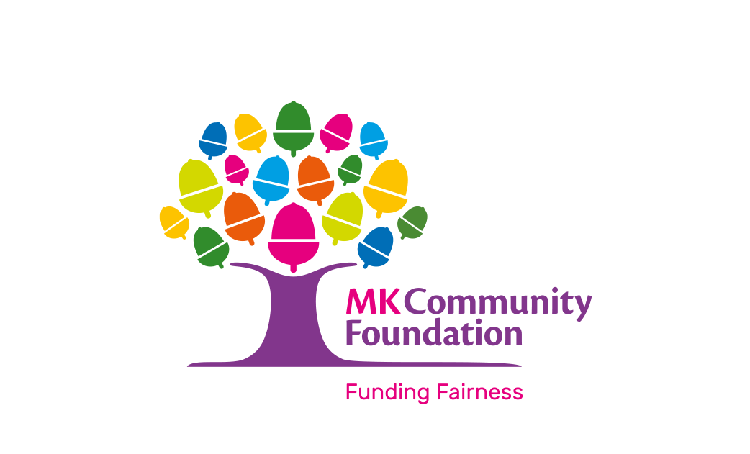

MK Community Foundation
Rent Subsidy Policy

Introduction

FUNDING FAIRNESS
Milton Keynes Community Foundation is an independent charity sending funding where it’s needed most in Milton Keynes. By guiding businesses, philanthropists and charities to the right giving and grants, we’re on a mission for a fairer community.
Our FAIR values:
- Fairness We seek detailed understanding to make the right decisions.
- Assistance We share our expertise and referrals for those who need advice.
- Inspiration We communicate our unique proposition passionately and with hope.
- Reliability We deliver what we say, when we say.

With our donors’ help we transform lives and strengthen communities across Milton Keynes.
- We support local people who are working to make a real difference to vulnerable, isolated, and disadvantaged people in MK.
- We provide a range of grant programmes to support both small grassroots groups right through to larger organisation working in the voluntary, community and cultural sector across MK.
- We make it easier for local people to support the whole community, giving money as individuals, families, and businesses.
- We make it easy for charities and Community Groups to apply for funding and support from us.

Our Strategic Goal over the next three years is to build a thriving, philanthropic, creative, equitable and FAIR community.

MK Community Foundation has a portfolio of property, which includes light industrial units, community shops, and several office buildings across the city, as well as a large conferencing centre in Central Milton Keynes. These provide a home and meeting spaces to a variety of Voluntary, Community and Cultural Sector Groups and businesses.
Our properties enable us to provide support to the Milton Keynes community. Surplus generated from the property portfolio are invested back into the property estate and the community through our charitable activities, in particular our grant making programmes. Support is also offered to the community through the availability of rent subsidies for the local Voluntary, Community and Culture Sector (VCCS).
Our grant making and support is guided by our Vital Signs research, which aims to collect the most up to date information about the issues affecting Milton Keynes, our impact goals and feedback from the local community, particularly the Voluntary, Community, and Cultural Sector.
Rent Subsidies
MK Community Foundation provides voluntary, community and culture sector organisations a variety of options of rental space available. Rent subsidies are designed to provide support to the sector and the discounted rate is subject to similar criteria as our grants programme. Rent subsidies form a significant proportion of the support that the Milton Keynes Community Foundation provides to the VCCS.
Rent Subsidies are available to eligible organisations, at levels of 75/50/25% of market rate for a 3-year period when they will be reassessed as part of a rent review period. The level of Rent Subsidy awarded is at the discretion of the Community Foundation, and is based on the following:
- an assessment of the benefit to the community of Milton Keynes.
- the financial position of the applicant organisation;
- type of organisation i.e., not for profit and good governance;
- previous grant history.
- Addressing emerging needs of the community as highlighted in the MK Community Foundation Vital Signs reports.
- Availability of rentable space.
- MK Community Foundation will allocate space determined by assessment of the needs of the group applying and in line with its commercial objectives.
- The Community Foundation having the ability to maintain a balance of subsidised rent and commercial rental income to sustain the ongoing management and maintenance of the estate.
- The Community Foundation reserves the right to refuse a rent subsidy at its discretion in line with its commercial and charitable objects.
In the interest of supporting the VCCS to build resilience, where appropriate subsidies offered may scale down or up at the 3-year rent review period.
Eligibility to Apply
We accept applications for Rent Subsidies from constituted, not-for-profit organisations working to benefit the community and/or residents of Milton Keynes Unitary Authority, including but not limited to:
- Local community groups, clubs or associations.
- Registered charities, including Charitable Incorporated Organisations (CIO).
- Faith organisations, where the primary activities to be delivered at the site are community-focussed and not for the promotion of religion, and where potential beneficiaries are not required to participate in religious activities, nor excluded on the basis of faith, religion, or lack thereof, or any other protected characteristics as defined in the Equality Act 2010.
- Social Enterprises and Community Interest Companies (CIC’s not for profit organisations), Companies Limited by Guarantee, and Companies Limited by Shares may be eligible where evidence is provided in governing documents that the organisation is not-for-profit, has an appropriate asset lock in place. Any shares must be reasonably limited, and directors must not be paid at a level that would make the provision of a subsidy inappropriate.
- Sports clubs.
All organisations must supply copies of:
- A governing document that details an appropriate asset lock and details that the organisation is not for profit.
- Committee/Board Member details including addresses.
- Financial records for a minimum of 3 years. The type required will depend on the size and structure of the organisation.
- A bank statement in the organisation’s name, for an account with at least two unrelated signatories.
- Equal Opportunities, Diversity and Inclusion Policy
- Child and Adult Safeguarding Policies (including Vulnerable Adult Policy if applicable).
- Business Plan covering the period of the requested subsidy.
- Where the activity is explicitly intended to generate surplus to fund charitable objectives of a charity a ‘Deed of Contract’ to enable surplus transfer is required.
- Last board/committee meeting notes where property requirements and the rent renewal were agreed.
- Community Interest Report (for CIC’s)
- Annual Report or AGM Minutes
- Sufficiency of documentation provided is determined during assessment and organisations submitting documentation that do not meet required standards may be withdrawn, at the discretion of the Community Foundation
- Where a specialist service is being delivered, relevant certification is required to demonstrate expertise and experience.
- Any other documentation relevant to the application

We are not able to accept applications from:
- Individuals and/or sole traders
- For-profit organisations, except for charitable trading arms of a charity
- Political parties or affiliated groups
- Faith organisations whose primary activities to be delivered within our properties include the promotion of religion.
- Any organisation whose community benefit and/or charitable objects do not include benefit for residents of the Milton Keynes Unitary Authority Area. Organisations whose benefit includes but extends beyond Milton Keynes may only be eligible for subsidies at a lower rate, proportionate to their reach in the local area.
- Any organisation whose primary benefit is animal welfare.
- Statutory organisations, schools, and academies, except where the provision of space is to facilitate non-statutory provision.
- Organisations that have been disqualified from Community Foundation Grant Programmes
- Extremist or organisations deemed to promote hate crime and as determined by the Community Foundation
Our properties may be available at full commercial rent for organisations that we are not able to subsidise, providing they align with the Vision and Values laid out in the MK Community Foundation Property Strategy and Policy.

Community Benefit
Community benefit is assessed against the following 5 main criteria. Please note that the bullet points under each criterion are intended as guidelines and are not a checklist to be “ticked off”:

Need and Demand (/10)
- Where the applicant organisation is providing trading activity, they can demonstrate their need for a subsidised rent.
- Evidence has been provided that there is a need for the main activities of the applicant organisation in Milton Keynes, particularly those that would be facilitated by any subsidised Community Foundation property.
- There is little or no other provision within or accessible to the communities that would be reached by the services delivered within the subsidised property.
- There is a financial need for support, for instance if a Rent Subsidy would enable an organisation to maintain presence in a location that would otherwise not be tenable, and the organisation would not be able to pay full commercial rates for these or other reasonable premises.
- Addresses at least one of the Vital Signs as reported in the current year of the Rent Subsidy application.

Reach and Impact (/10)
- The applicant organisation is well positioned within the Milton Keynes Unitary Authority area to reach its intended beneficiaries. For instance, this may include details of existing reach, or links or partnerships with other established local organisations.
- The applicant organisation possesses the relevant skills and expertise amongst its staff and/or board to deliver their intended impact.
- The applicant organisation can demonstrate relevant accreditation.
- The impact of the activities to be delivered on the intended beneficiaries is appropriately evidence-based.
- A reasonable proportion of the existing beneficiaries of the organisation are residents of the Milton Keynes Unitary Authority Area, or the applicant can demonstrate a reasonable estimate of how a Rent Subsidy would support them to reach a reasonable number of residents.
- The Rent Subsidy will enable the organisation to maintain a presence in or be accessible to the communities that it serves, or will support the group to address barriers to service provision (e.g., cost)
- The subsidised space would be in sufficient use such that the offer of a subsidy could be deemed good value for money.

Inclusion & Diversity (/10)
• The organisation is fully inclusive and has considered differing needs within the diverse communities of MK
• Reflects an awareness of the 9 protected characteristics (age, disability, gender reassignment, marriage and civil partnership, pregnancy and maternity, race, religion, or belief, sex, and sexual orientation) in terms of delivery of its core services
- Demonstrates active outreach to engage diverse communities.

Financial Sustainability (/5)
- The group is financially sound and has taken steps and explored all possible routes for fundraising. The organisation has provided clear and transparent documentation to demonstrate sound financial management.
- The group have demonstrated and evidenced a diverse and broad range of funding income.
- The organisation has provided Key Performance Indicators for fundraising or income with the business plan.
- The organisation has developed an effective risk mitigation plan to ensure payment of rent for the duration of the lease.
- The organisation has long term financial planning in place, considering inflation, future funding requirements and changes to rent subsidy levels.
- The organisation does not hold reserves above the reserves policy as set by the organisation’s board of trustees
Group Profile (/5)
- Previous monitoring for Rent Subsidies and/or Grants has been submitted on time, to a good standard.
- There is a good record of sound financial and project management.
- Provided governing documents and policies that comply with criteria.
- The organisation has reputable endorsements from individuals and or other organisations.
- The organisation has a record of enterprise or fundraising.
- The organisation has a history of reaching seldom heard/asked beneficiaries and/or supporting Vital Signs priority areas.
- The organisation has agreements in place to share any surplus above and beyond expected level with the Community Foundation.

Rent Subsidy Levels
Rent subsidies will be awarded on a sliding scale basis and will consider the above criteria:
75% Subsidy: Scores of 32 and above
50% Subsidy: Scores of 27-31
25% Subsidy: Scores of 20-26

Rent Subsidy Renewals
All organisations are eligible to apply to renew their Rent Subsidy for the period following their application, though the terms of their Rental Agreement may change. Renewals are not guaranteed, organisations may not be awarded the same proportion or value of Rent Subsidy of which they were already in receipt and may be moved up or down the rent subsidy levels as outlined above.
Additional considerations will be made when considering an application for renewal of an existing Rent Subsidy, including but not limited to:
- Whether the organisation has taken reasonable steps to reduce their reliance on a Community Foundation Rent Subsidy, or reliance on Community Foundation Grant Programmes, where relevant.
- Whether the organisation has fulfilled the conditions of the Rent Subsidy as detailed in their Rent Subsidy Agreement, which include the appropriate acknowledgement of receipt of the Rent Subsidy, for example in publicity and marketing materials.
- Whether the circumstances or position of the applicant organisation has changed, such as the financial position, structure, or governance of the organisation.
- Whether the level of need for such services in Milton Keynes has changed since the previous Rent Subsidy was awarded.
- Whether the applicant organisation has demonstrated the impact of a previous Rent Subsidy or Subsidies, and if they can demonstrate the way their organisation is incorporating learning and reflection into its delivery.
- Any trading arm of a charity, CIC or Social Enterprise will be expected to reduce their reliance on rent subsidy due to increase in trading.

Additional Space
Organisations with an existing subsidy may apply for a Rent Subsidy for additional Community Foundation property, and there is no fixed maximum on the number of Community Foundation properties that may be leased at a subsidised rate. However, additional subsidies are not guaranteed, and a distinct case must be made in the application for each rental, the rent subsidy award will be assessed according to the criteria stated above.
Applications will be considered on a case-by-case basis against the criteria laid out in this policy and the Community Foundation’s Property Strategy, the Strategic Plan and availability of appropriate units.
Subletting
Where a request is made to sublet part of the subsidised property, and where permission has been granted, the sublet rent must not exceed the value of the subsidised rent the main leaseholder pays. Any rent received above this value must be reverted to the MK Community Foundation.

Procedure

All applications to the MK Community Foundation for subsidised rent are subject to a rigorous assessment against the criteria outlined above.
An assessment of the Community Benefit is conducted by the Philanthropy Team, using a scoring matrix based on the criteria outlined in the policy. A Financial Assessment is conducted by the Director of Finance.
A recommendation is made by the Philanthropy Team and the Director of Finance to the rent subsidy panel for approval.
Terms of the Rental Agreement tenancies are considered separately from the application for a Rent Subsidy by the Estates Management team.

  - New Applications for Rent Subsidies
Applicants seeking a new Rent Subsidy from the Community Foundation should first identify the property and its market rate for which they are seeking a subsidy through our Estates team, or through the Conference Team if the office space is in our Central Milton Keynes buildings, Acorn House and Margaret Powell House.
They will then be supplied with a link to the online application form.
For applications for new and additional subsidies, we aim for a turnaround time of ix months from submission for a final decision, unless further information is required.
  - Applications for Rent Subsidy Renewals
Applications to the Community Foundation should be received a minimum of twelve months in advance of the end of the current Rent Subsidy period.,

  - Rent Subsidy Agreements
All rent subsidies will be set out in a Rent Subsidy Agreement document. The agreement will include.
- Details of any conditions of operation
- Details of profit share arrangements

  - Publicity and Marketing
All awarded Rent Subsidies are subject to conditions that require subsidised organisations to acknowledge the Community Foundation’s support, including on subsidised organisations’ websites, in print materials and press coverage, and through social media.
The Community Foundation reserves the right to publicise all awarded Rent Subsidies, and will request to visit subsidised properties, possibly with guests.

  - Monitoring and Impact
All subsidised organisations must report back to the MK Community Foundation every 12 months at a minimum. These can take the form of a written report, or through a meeting with a member of the Philanthropy Team. Reports should address:
- The impact of the Rent Subsidy on the organisation, in terms of capacity and sustainability
- The impact of the Rent Subsidy on the difference made to beneficiaries.
Please see the MK Community Foundation Monitoring, Evaluation, and Impact Policy for further details.

